Assignment  
Webpage

**HTML Code:**

<!DOCTYPE html>

<html lang="en">

<head>

<meta charset="UTF-8">

<meta name="viewport" content="width=device-width, initial-scale=1.0">

<title>Vintage Train Collection</title>

<link rel="stylesheet" href="styles.css">

</head>

<body>

<header>

<nav>

<ul>

<li><a href="#home">Home</a></li>

<li><a href="#gallery">Gallery</a></li>

<li><a href="#specs">Specifications</a></li>

<li><a href="#contact">Contact</a></li>

</ul>

</nav>

</header>

<main>

<section id="home">

<h1>Vintage Train Collection</h1>

<p>Explore the golden age of rail transportation</p>

</section>

<section id="gallery">

<h2>Train Gallery</h2>

<div class="gallery-container">

<div class="gallery-item">

<img src="https://images.unsplash.com/photo-1474487548417-781cb71495f3?w=500&h=400&auto=format" alt="Orient Express">

<h3>Orient Express</h3>

<div class="train-info">

<p>The legendary Orient Express, launched in 1883, connected Paris to Constantinople.</p>

<p>Max Speed: 80 mph</p>

</div>

</div>

<div class="gallery-item">

<img src="scotsman.jpg" alt="Flying Scotsman">

<h3>Flying Scotsman</h3>

<div class="train-info">

<p>First steam locomotive to officially reach 100 mph.</p>

<p>Max Speed: 100 mph</p>

</div>

</div>

<div class="gallery-item">

<img src="union.jpeg" alt="Big Boy">

<h3>Union Pacific Big Boy</h3>

<div class="train-info">

<p>The largest steam locomotive ever built.</p>

<p>Weight: 1.2 million pounds</p>

</div>

</div>

<div class="gallery-item">

<img src="siberian.jpg" alt="Trans-Siberian">

<h3>Trans-Siberian Express</h3>

<div class="train-info">

<p>World's longest railway journey.</p>

<p>Distance: 5,772 miles</p>

</div>

</div>

<div class="gallery-item">

<img src="malard.webp" alt="Mallard">

<h3>Mallard</h3>

<div class="train-info">

<p>World speed record holder for steam locomotives.</p>

<p>Max Speed: 126 mph</p>

</div>

</div>

<div class="gallery-item">

<img src="royal.jpg" alt="Royal Hudson">

<h3>Royal Hudson</h3>

<div class="train-info">

<p>Famous Canadian steam locomotive.</p>

<p>Max Speed: 70 mph</p>

</div>

</div>

<div class="gallery-item">

<img src="k4s.jpeg" alt="Pennsylvania K4s">

<h3>Pennsylvania K4s</h3>

<div class="train-info">

<p>Most successful passenger steam locomotive.</p>

<p>Max Speed: 90 mph</p>

</div>

</div>

<div class="gallery-item">

<img src="gs4.jpeg" alt="Southern Pacific">

<h3>Southern Pacific GS-4</h3>

<div class="train-info">

<p>Known for its distinctive orange livery.</p>

<p>Max Speed: 100 mph</p>

</div>

</div>

<div class="gallery-item">

<img src="road.jpeg" alt="Hiawatha">

<h3>Milwaukee Road Hiawatha</h3>

<div class="train-info">

<p>Famous for its streamlined design.</p>

<p>Max Speed: 100+ mph</p>

</div>

</div>

<div class="gallery-item">

<img src="nyc.jpeg" alt="NYC Hudson">

<h3>NYC Hudson</h3>

<div class="train-info">

<p>Flagship locomotive of New York Central Railroad.</p>

<p>Max Speed: 95 mph</p>

</div>

</div>

</div>

</section>

<section id="specs">

<h2>Train Specifications</h2>

<div class="table-container">

<table>

<thead>

<tr>

<th>Train Type</th>

<th>Year</th>

<th>Max Speed</th>

<th>Power Source</th>

<th>Country of Origin</th>

</tr>

</thead>

<tbody>

<tr>

<td>Orient Express</td>

<td>1883</td>

<td>80 mph</td>

<td>Steam</td>

<td>France</td>

</tr>

<tr>

<td>Flying Scotsman</td>

<td>1923</td>

<td>100 mph</td>

<td>Steam</td>

<td>United Kingdom</td>

</tr>

<tr>

<td>Big Boy</td>

<td>1941</td>

<td>80 mph</td>

<td>Steam</td>

<td>United States</td>

</tr>

<tr>

<td>Mallard</td>

<td>1938</td>

<td>126 mph</td>

<td>Steam</td>

<td>United Kingdom</td>

</tr>

<tr>

<td>NYC Hudson</td>

<td>1927</td>

<td>95 mph</td>

<td>Steam</td>

<td>United States</td>

</tr>

</tbody>

</table>

</div>

</section>

</main>

<footer>

<div id="contact">

<h3>Contact Us</h3>

<p>Email: sampath@gmail.com</p>

<p>Phone: 9999999999</p>

</div>

<div id="licensing">

<p>&copy; 2025 Vintage Train Collection. All rights reserved.</p>

</div>

</footer>

</body>

</html>

**CSS Code:**

body,

html {

margin: 0;

padding: 0;

font-family: "Georgia", serif;

scroll-behavior: smooth;

}

body {

background-image: url("https://hebbkx1anhila5yf.public.blob.vercel-storage.com/backgroundtrain.jpg-BxREsziENcY8lssPkQ0LjImTMX78ed.jpeg");

background-size: cover;

background-attachment: fixed;

background-position: center;

color: #333;

}

header {

background-color: rgba(20, 20, 20, 0.9);

position: fixed;

width: 100%;

top: 0;

z-index: 1000;

}

nav ul {

list-style-type: none;

padding: 0;

margin: 0;

display: flex;

justify-content: center;

}

nav ul li a {

color: #d4af37;

text-decoration: none;

padding: 15px 20px;

display: inline-block;

transition: all 0.3s ease;

font-size: 1.1em;

}

nav ul li a:hover {

background-color: rgba(212, 175, 55, 0.2);

transform: translateY(-3px);

text-shadow: 0 0 5px #d4af37;

}

main {

padding-top: 60px;

}

section {

padding: 50px 20px;

background-color: rgba(20, 20, 20, 0.85);

margin: 20px auto;

max-width: 1200px;

color: #fff;

}

h1,

h2,

h3 {

color: #d4af37;

text-align: center;

}

#home {

text-align: center;

padding: 100px 20px;

margin-top: 0;

}

#home h1 {

font-size: 3.5em;

margin-bottom: 20px;

text-shadow: 2px 2px 4px rgba(0, 0, 0, 0.5);

}

.gallery-container {

display: grid;

grid-template-columns: repeat(auto-fit, minmax(300px, 1fr));

gap: 20px;

padding: 20px;

}

.gallery-item {

background-color: rgba(255, 255, 255, 0.1);

border: 1px solid #d4af37;

border-radius: 8px;

overflow: hidden;

transition: all 0.3s ease;

position: relative;

}

.gallery-item img {

width: 100%;

height: 250px;

object-fit: cover;

transition: all 0.3s ease;

display: block;

}

.gallery-item h3 {

padding: 15px;

margin: 0;

background-color: rgba(20, 20, 20, 0.9);

}

.train-info {

position: absolute;

top: 0;

left: 0;

right: 0;

bottom: 0;

background-color: rgba(20, 20, 20, 0.9);

color: #fff;

padding: 20px;

opacity: 0;

transition: opacity 0.3s ease;

display: flex;

flex-direction: column;

justify-content: center;

text-align: center;

}

.gallery-item:hover .train-info {

opacity: 1;

}

.gallery-item:hover img {

transform: scale(1.1);

}

.table-container {

overflow-x: auto;

margin: 20px 0;

}

table {

width: 100%;

border-collapse: collapse;

background-color: rgba(255, 255, 255, 0.1);

margin: 20px 0;

}

th,

td {

padding: 12px 15px;

text-align: left;

border: 1px solid #d4af37;

}

th {

background-color: rgba(212, 175, 55, 0.2);

color: #d4af37;

}

tr:hover {

background-color: rgba(212, 175, 55, 0.1);

}

footer {

background-color: rgba(20, 20, 20, 0.9);

color: #fff;

padding: 20px;

text-align: center;

}

footer div {

margin: 10px 0;

}

@media (max-width: 768px) {

nav ul {

flex-direction: column;

align-items: center;

}

nav ul li a {

padding: 10px;

}

#home h1 {

font-size: 2.5em;

}

.gallery-container {

grid-template-columns: 1fr;

}

}

**Output:**

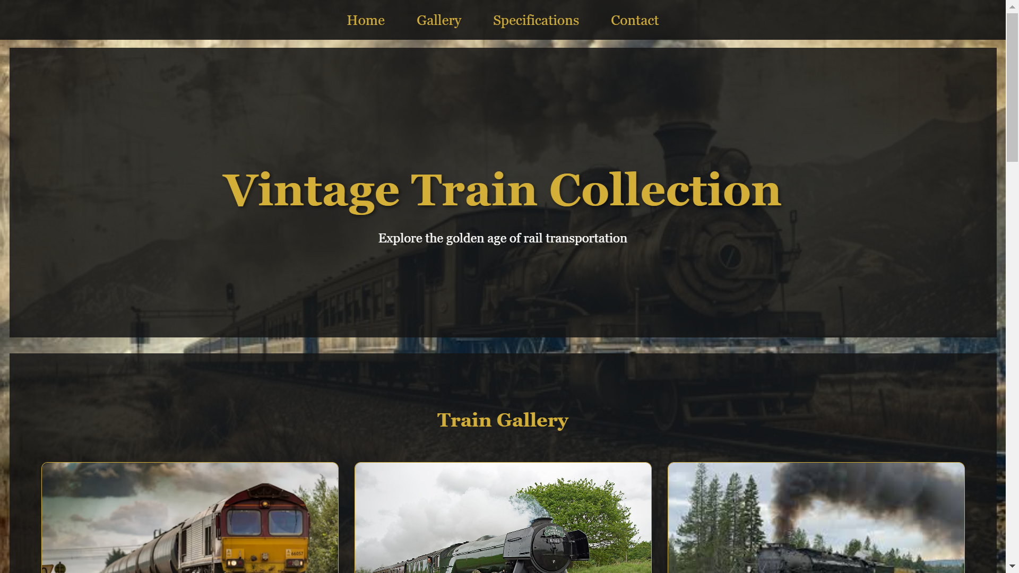

**Train Gallery:**

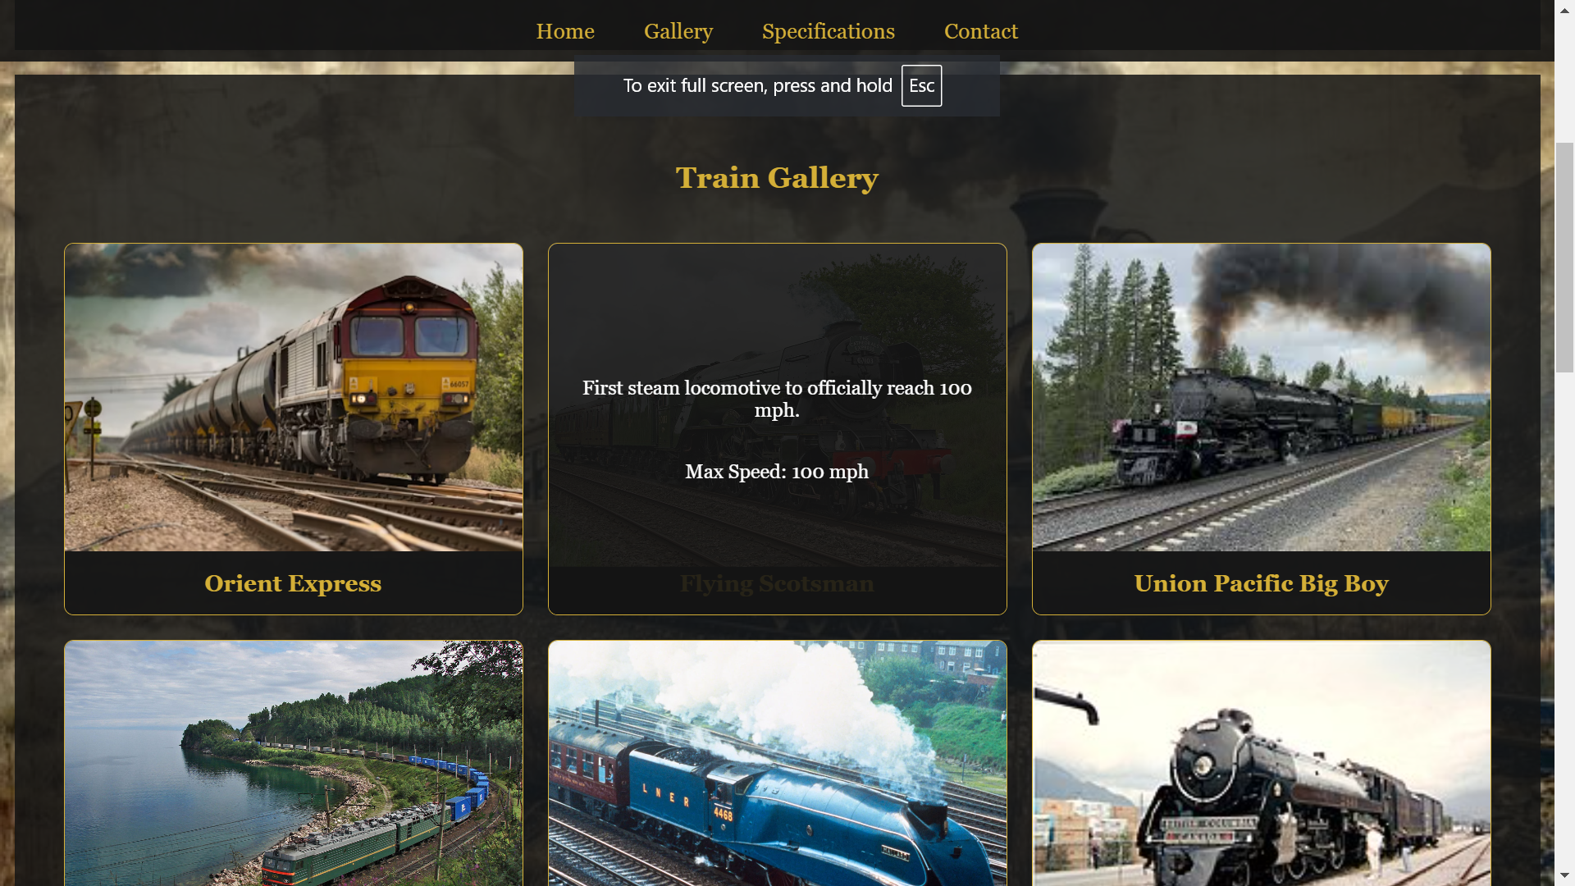

**Transport Specification:**

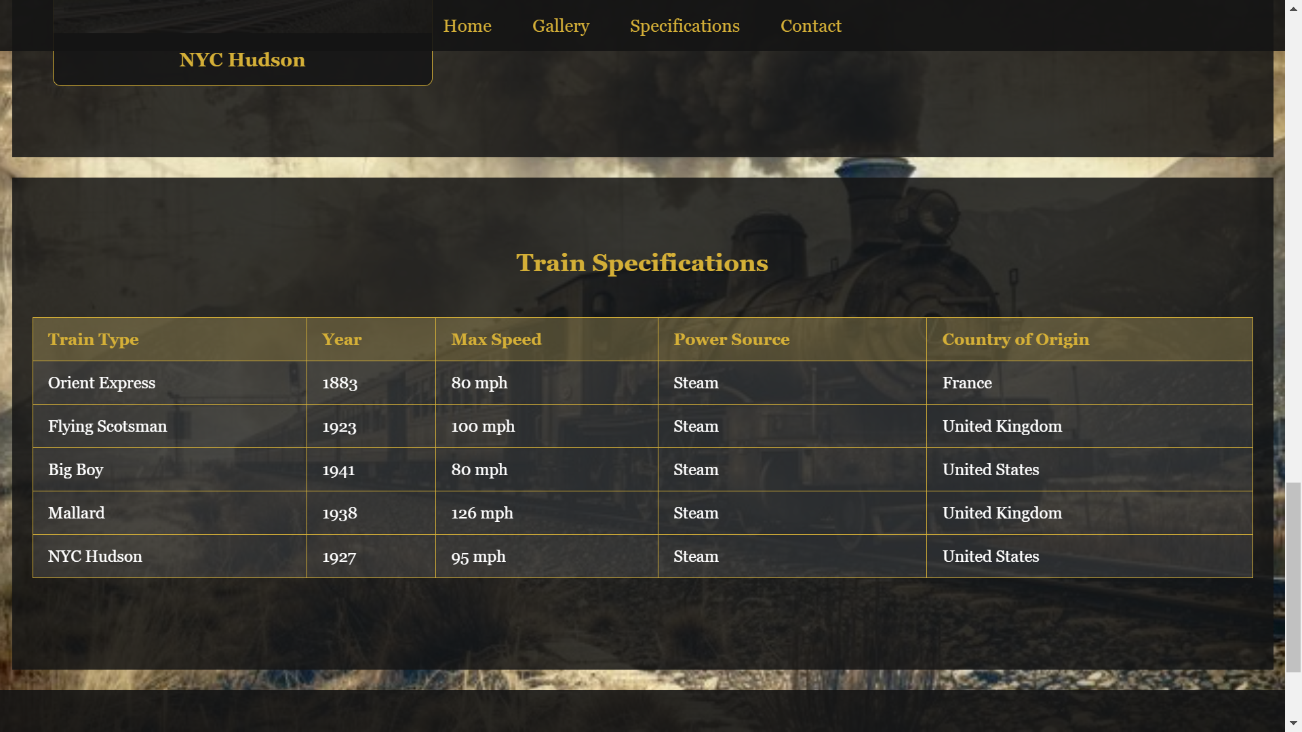

**Contact:**

